Data Availability Guide
The following steps will be required for the majority of projects accessing the datasets described below:
- Patients must be meaningfully engaged in defining the research question (See SCPOR PORLET tool here)
- Projects need to be approved through the SCPOR Detailed Support Request Process. (Visit this link to learn more)
- Data Sharing Agreements with the data stewards or trustees that will be providing data for the project.
- Ethics approval or exemption (the majority of administrative database projects are low risk and eligible for delegated review).
- Contracts or Collaboration Agreements between the researcher’s institution and Health Quality Council and/or eHealth Saskatchewan.
- Confidentiality Agreements.
The following datasets are the easiest to access (upon completion of the steps described above) and have been used extensively for research purposes in Saskatchewan. Data quality and limitations on use for research purposes are most extensively documented for these datasets. They can also be linked at the record level using encrypted health card numbers.
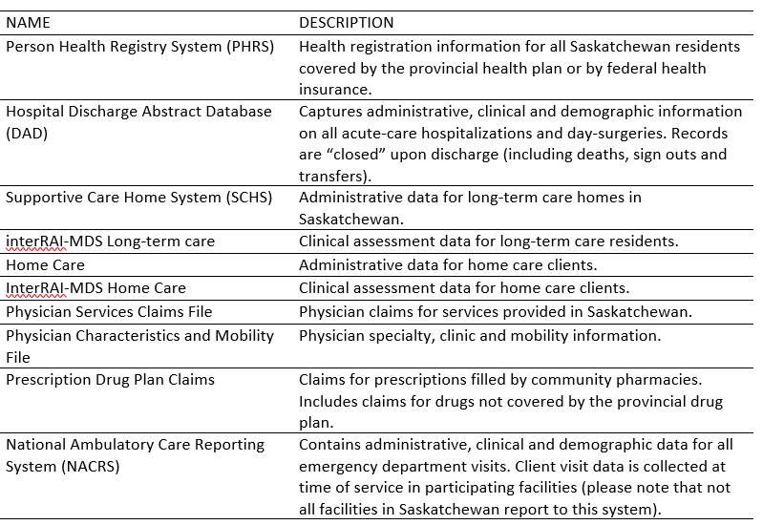

The datasets below can also be accessed for research purposes; however since they are primarily administrative or clinical in nature and have not been frequently used for research, the data quality is less well known. For these datasets, more time may be required for data extraction and cleaning – please plan your timelines accordingly. If your research requires one of these datasets, please contact the Data Services Platform early in your planning to determine the feasibility of your request.
Name | Description
Ambulance System Management (ASM) | This system contains information pertaining to: call and trip details, patient information, ambulance time record, vehicle information, history and examination, treatment, and invoice information.
Saskatchewan Surgical Care Network (SSCN) | Provincial registry of all major surgical events performed throughout the province.
National Rehabilitation Reporting System (NRS) | Rehabilitation care includes a comprehensive range of inpatient and outpatient services and complex continuing care for adults who experience debilitating illness or injury.
Alcohol, Drug & Gambling (ADG) | Tracks people and service events for patients enrolled in alcohol, drug abuse and gambling treatments.
Acquired Brain Injury (ABIIS/ABI) | Tracks people and service events for patients with brain injuries.
Radiology Information System (RIS) | Scheduling and co-ordination of diagnostic imaging orders and results for patients (centrally hosted RIS).
Chronic Disease Management-Quality Improvement Program (CDM-QIP) | Clinical data collected to improve care for chronic disease patients. Currently data is collected by participating clinics for: coronary artery disease, diabetes, chronic obstructive pulmonary disease and heart failure.
Prescription Review Program (PRP) | The Prescription Review Program database contains Prescription Drug Plan Claims data only for the specific controlled substances that are monitored as part of the program.

The data described below are large clinical information systems that have been implemented within Saskatchewan. While it is possible to access these datasets for research purposes, it has rarely been done and therefore data quality for research purposes is unknown. These systems have also been implemented in different ways, at different times, across the province, resulting in significant variation in how individual fields are coded; consolidation and integration are occurring however will take time. If your research is likely to involve one of these datasets, please contact the Data Services Platform early in your planning to determine the feasibility of your request and timelines for access.
Name | Description
Surgical Information System/OR Manager | This application manages the booking and charting of surgical procedures as well as integrating with materials management.
Shared Client Index (SCI) | The Provincial Client Registry. The application has a complex algorithm which links records across clinical information systems to create one identity “record” per person. This identity is different than the Health Services Number.
Sunrise Clinical Manager (SCM) | Acute care electronic medical record. Please note that this system has not been fully implemented across the province.
Provider Registry System (PRS) | The provincial registry of health care providers, that is fed by the several colleges (Surgeons-CPSS, Dentists-CDSS, Pharmacists-SCP, Nurses-SRNA [currently only Nurse Practitioners], Optometrists - SAO, Midwives-SAM, Ministry-MSB).

For more information, please contact one of the platform co-leads:
Meric Osman Scott Wells
mosman@hqc.sk.ca scott.wells@ehealthsask.ca
306-668-8810 ext. 146 306-337-0651

